Hubbub:  
A Guide to Discovery

Taylor Ereio Ali Hamie Zach Diemer Ricardo Noriega

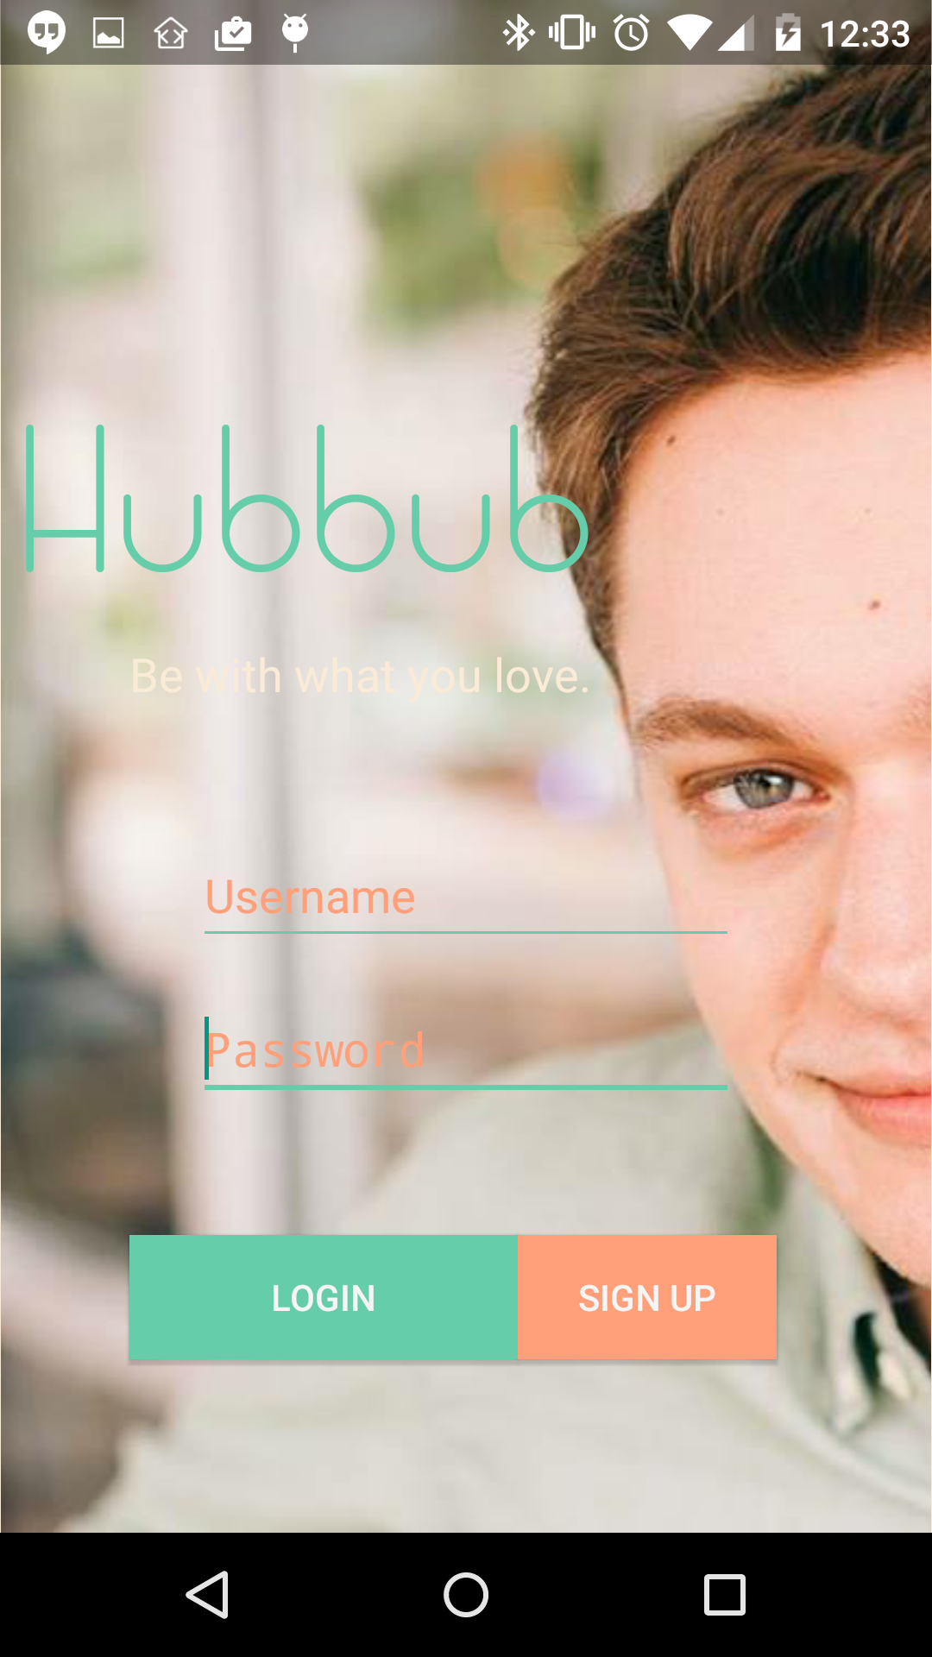

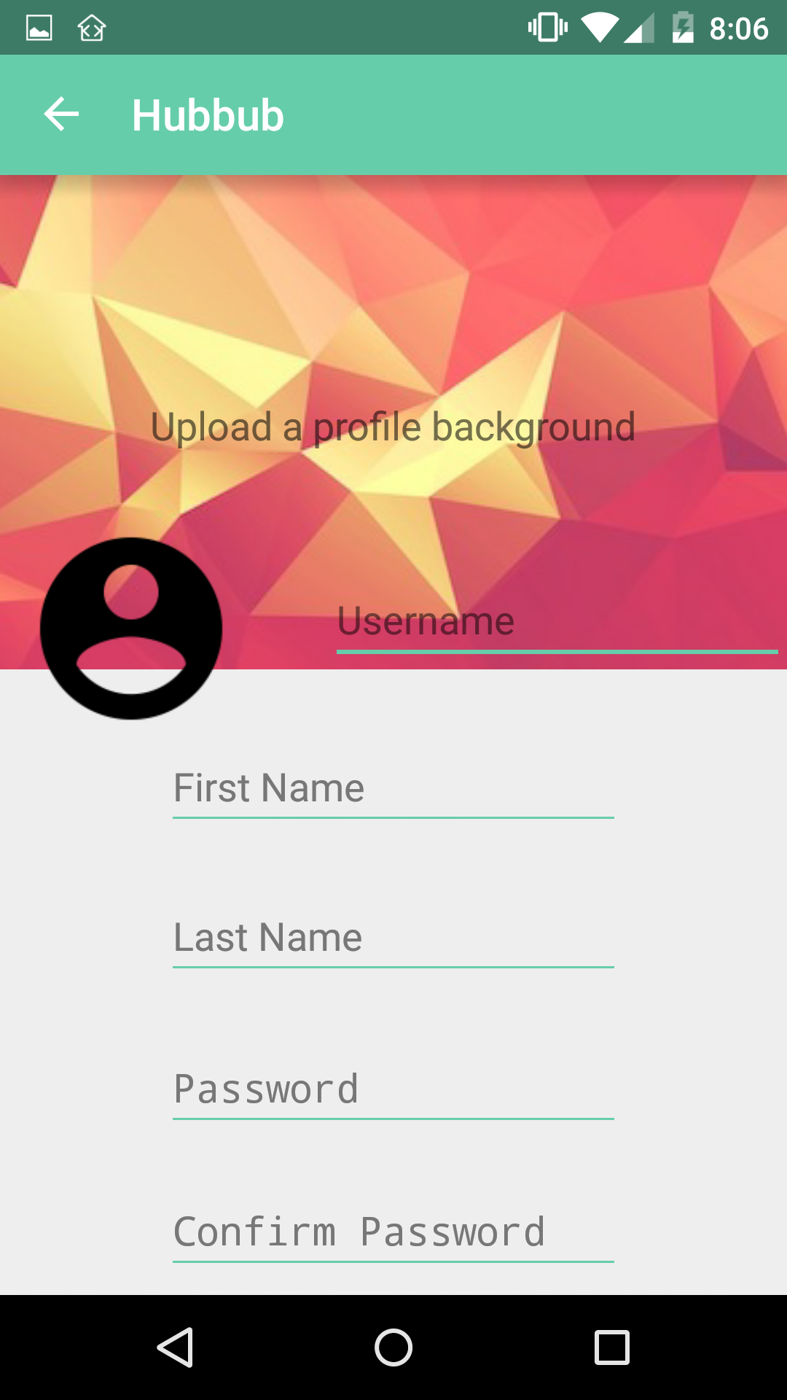

Creating an Account:

* Creating an account is as easy as typing in the required information necessary.
* Users will be restricted to student only at the beginning of release and will need .edu emails addresses in order to sign up.
* Users will need to provide:
  + First and Last names
  + Password
  + Email
  + Date of Birth
  + Optional
    - A background picture
    - The about me section

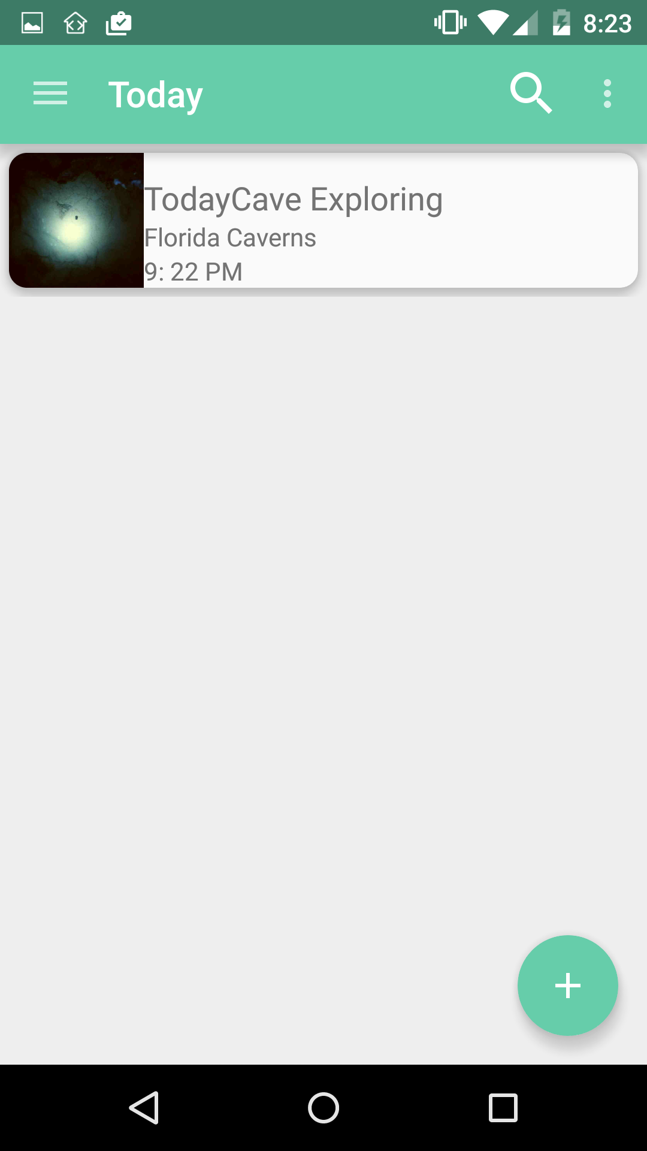

Exploring Today’s Events:

* As soon as a user is signed in they can explore today’s events, whether posted by business or users
* By clicking on an event in the list, users will be brought to a page where they will receive more information listed on each event.
* Everything is geolocated, thus users will only be able to see Today’s events based on the location they currently are in.
* Locations are based usually on the city or town they are currently located in.

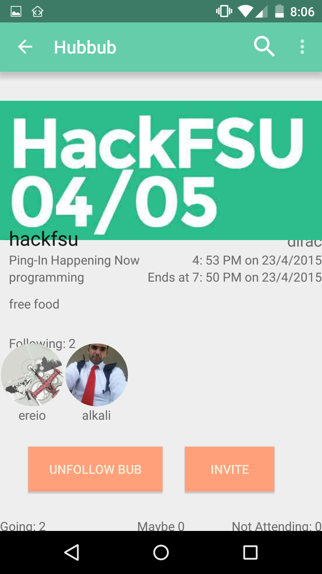Viewing Event Details:

* After selecting an event anywhere they are previewed, users will be taken to a window to preview details and attendees.
* Users can select people attending to view their profile and see more information on that user
* If the event has begun, users can view who has said they are going, maybe going, or not going to better make a decision if they should go.
* Additionally, users can invite other users to the selected event from here

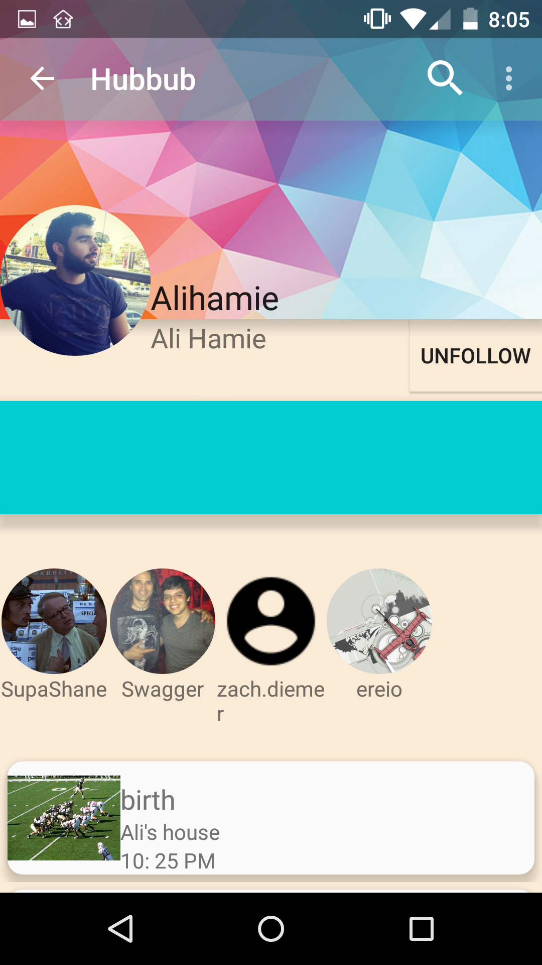

Viewing User Details:

* Users can view peoples profiles from event and hub pages just by clicking on their profile picture
* Here, users can view details about that user in the about me panel if a user has provided any information about themselves
* Users can further navigate to other user profiles
* Events followed by the user viewed are also listed to better communicate event discovery

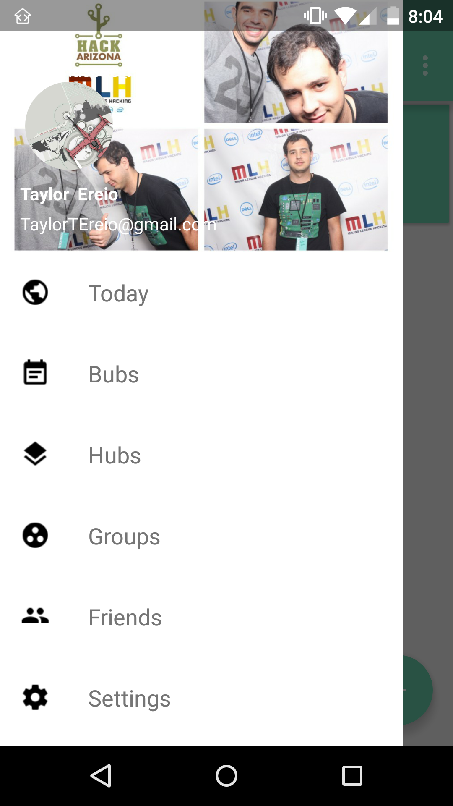User Navigation Drawer:

* Users can navigate the app using the navigation drawer.
* This drawer is available at any time within the main user window of hubbub. Meaning, only when you’re not viewing a bub, hub, or a user.
* This will give you access to many of the users main materials including subscribed hubs and their current friends list.

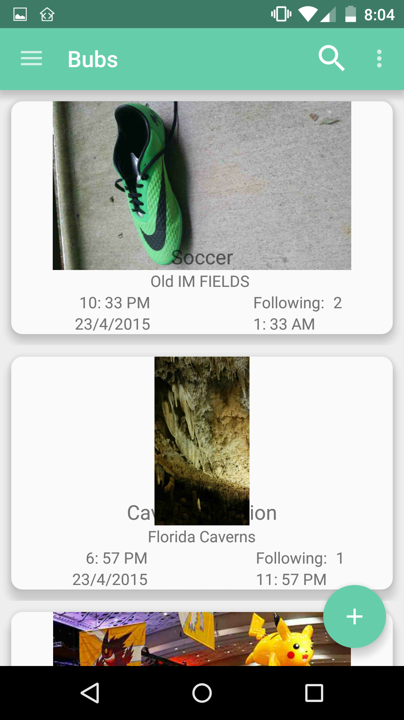

Viewing User Bubs:

* By clicking on the Bub’s section of the user drawer, users will be able to view their followed events
* Since users will have already followed, and been interested in attending, the event, more information will be provided to them regarding the event within the list view
* Allowing users to quickly see location and start times will ensure the quick reconnection to event information

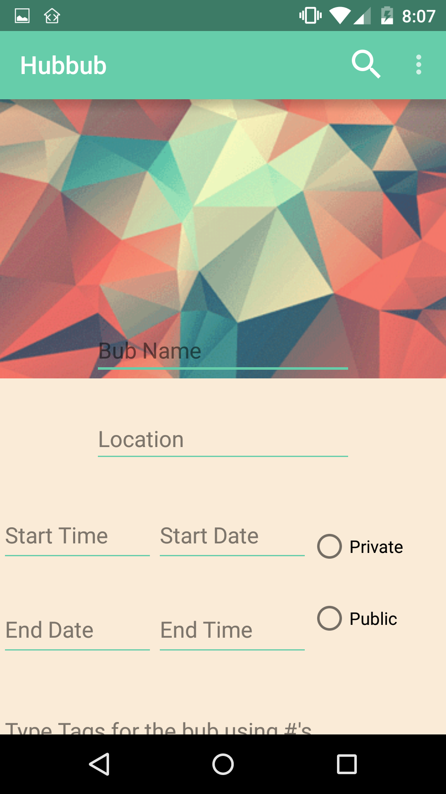Creating New Bubs:

* Creating new events is as easy as clicking the plus action button on any window other than the users hubs page
* Users can set important details like the following:
  + Name
  + Location
  + Start Time and Date
  + End Time and Date
  + Privacy of event
  + Tags to search by
  + Any specific details or more description info

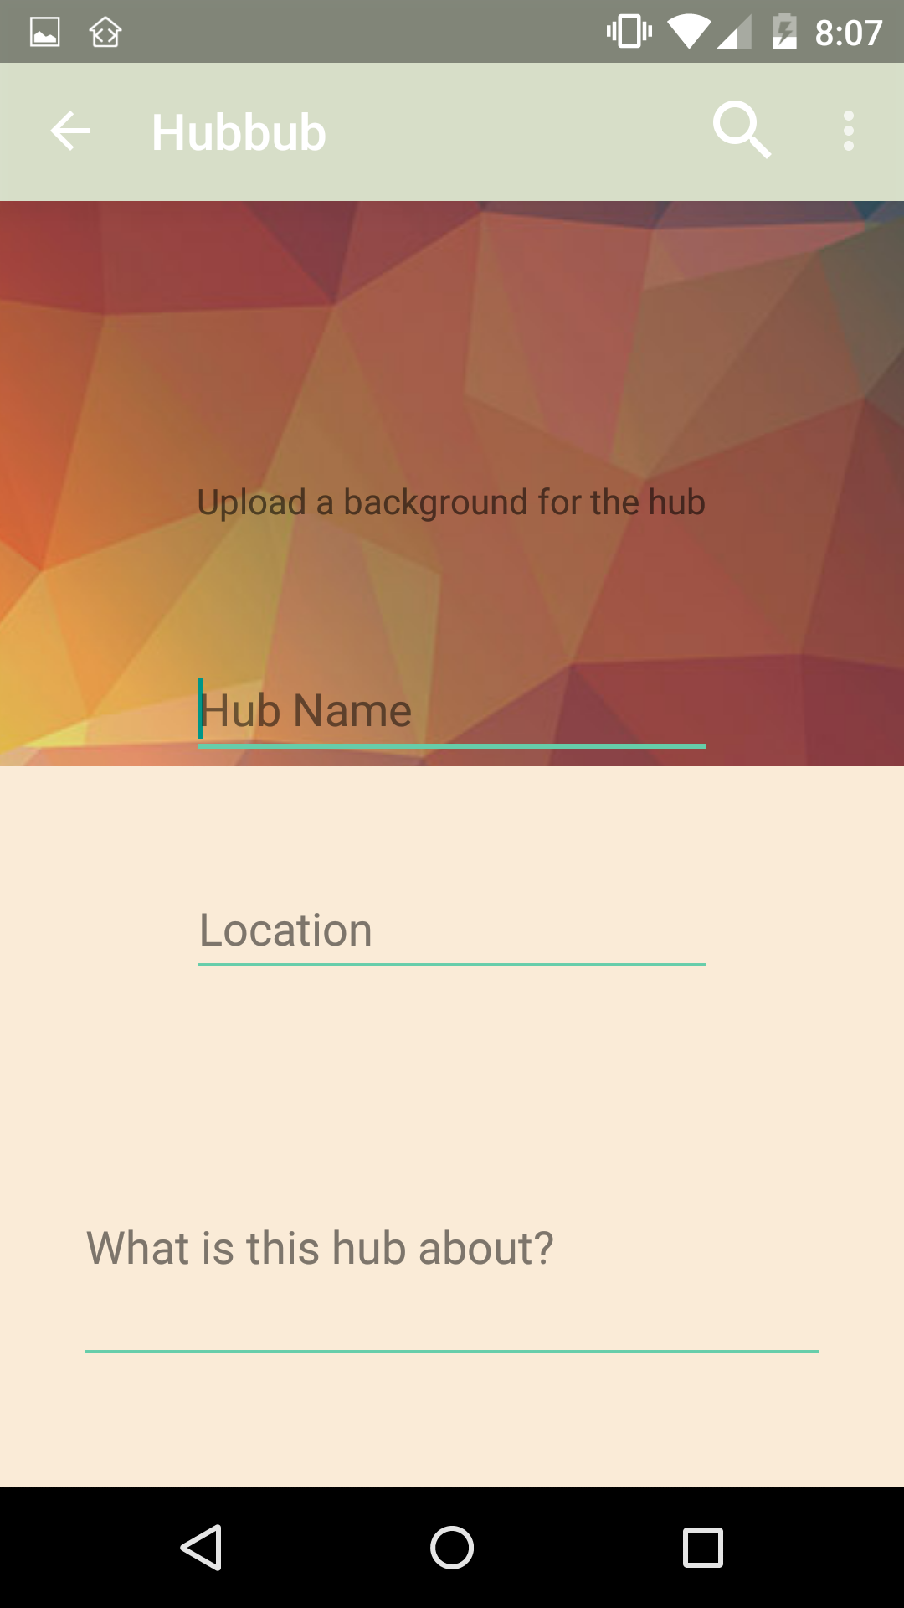

Creating New Hubs:

* Hubs can be created clicking the action button on the users hubs page
* Hubs encompass all events under specific tags so types of events can be grouped under specific interests
* Hubs are already geolocated but users can set specific locations. For example, a popular bar could have it’s own hub, and thus it’s own address!

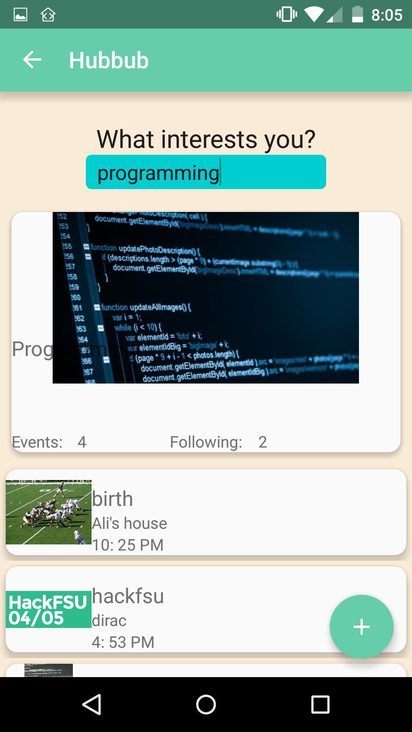Searching Events and Hubs:

* Users can type in a interest by topic or “hashtag” and the results will populate below the bar
* Searching events and hubs happens simultaneously
* Users can search by interest, see and select what interests them most from their search
* Additionally, if they can’t find what they are looking for, the option to create a bub is also located on this page

We hope you enjoy using Hubbub!